The Biblical DISPENSATIONS of History

DISPENSATION DEFINED:
- A particular way of God’s administering His rule over the world as He progressively works out His purposes for world history.

“That in the dispensation of the fulness of times He might gather together in one all things in
Christ, both which are in heaven, and which are on earth; even in Him:” - Ephesians 1:10

- A dispensation is not necessarily an age or a certain period of time. Some dispensations are divided into separate periods of time, such as the dispensation of the Law.

“Know therefore and understand, that from the going forth of the commandment to restore and to build Jerusalem [This took place on the 5th March, 444BC (See Nehemiah 2:1-8 ] unto the Messiah the Prince shall be seven weeks, and threescore and two weeks: [i.e., 7 + 60 + 2 = 69 weeks or literally “sevens”; 69 x 7 years = 483 Jewish years of 360 days per year or 476 Gregorian years of 365 days per year plus leap year days.] the street shall be built again, and the wall, even in troublous times [This took 49 years to rebuild Jerusalem or 7 x 7 years] . And after threescore and two weeks [another 62 x 7 years, i.e., 434 years after the rebuilding of Jerusalem] shall Messiah be cut off, but not for Himself: [30th March, 33AD, the time of Christ’s final week as He entered Jerusalem] and the people of the prince that shall come [i.e., the Antichrist] shall destroy the city and the sanctuary; and the end thereof shall be with a flood [i.e., an attack – see Psalm 124:2-5], and unto the end of the war desolations are determined. And he shall confirm the covenant [i.e., peace treaty with Israel] with many for one week [one more lot of 7 years at a future time that we call “The Tribulation,” or the “time of Jacob’s trouble” Jeremiah 30:7]: and in the midst of the week he shall cause the sacrifice and the oblation to cease, and for the overspreading of abominations he shall make it desolate, even until the consummation, and that determined shall be poured upon the desolate.” - Daniel 9:25 – 27

- A dispensation may involve God’s rule over all mankind, or over only one segment of mankind, such as the people of Israel.

“These are the statutes and judgments and laws, which the LORD made between Him and the
children of Israel in mount Sinai by the hand of Moses.” - Leviticus 26:46
CHARACTERISTICS OF A DISPENSATION:
- A particular way of God’s administering His rule.
- A particular responsibility for man.
- A divine revelation which had not been given before.
- Each dispensation applies a test to man to see whether he will obey the responsibility which characterises that dispensation.
- Each dispensation demonstrates the failure of man to obey that particular rule of God which characterises that dispensation.
- Each dispensation involves divine judgment because of man’s failure.


THE NEW HEAVENS & THE NEW EARTH

ETERNITY PAST
innocence
CONSCIENCE
GOVERNMENT
PROMISE
MOSAIC LAW
GRACE
MILLENIUM

THE DISPENSATION OF INNOCENCE:
- The Time. This era began with the Forming of man and ended with the Fall of man

- This was the innocent or unfallen state when mankind was neither righteous nor sinful
because they had not chosen good nor evil.

- Man was created with a favourable disposition towards God, but was on probation as to
whether he would choose to continue that way.

- God’s Revelation for the first dispensation is recorded in Genesis 1:28,29; 2:15-17, 24

- Man was to live in a loving marital Relationship.

- They were to Reproduce themselves.

- They were to exercise Rule over the animal and plant life.

- They were to Raise and Retain the garden.

- They had the Right to eat of any tree of the garden except one.

- Man’s Responsibility was to obey God on the basis of His unconfirmed favourable disposition toward him.

- Man’s Test: Would man obey God on the basis of his unconfirmed favourable disposition, or would he fail this period of probation?

- Man’s Failure: Man rejected God’s rule over him and refused to believe His warnings.
He revealed his choice by eating the fruit that was forbidden by God in violation of His command.

- Man’s Judgment: Man died spiritually – Genesis 2:17

- Man’s favourable disposition toward God was replaced with enmity against God -Romans 8:7

- They became subject to disease, deformity, injury, sorrow and physical death.

- The woman would suffer distress in childbirth and a desire to rule her husband.

- Man’s effort to grow food would be more difficult.

- They would be driven from the Garden of Eden


THE DISPENSATION OF CONSCIENCE:

- The T was between the Fall of man and Noah’s Flood
Genesis 4:1 – 8:19

- Man lost his favourable disposition towards God that he had in the
Garden of Eden.

- God now used two new ruling factors to govern man in this new
Dispensation.

- The first ruling factor was the human c .

“For when the Gentiles, which have not the law, do by nature the things contained in the law,
these, having not the law, are a law unto themselves: Which shew the work of the law
written in their hearts, their conscience also bearing witness, and their thoughts the mean
while accusing or else excusing one another;)” Romans 2:14,15

- The conscience is the awareness of right and wrong which exists inside human beings.

- Man obtained this awareness of good and evil as a result of eating the forbidden fruit.
See Genesis 3:5 and 22

- The human conscience began when man rebelled against God.

- The second ruling factor was the r of the Holy Spirit.

“And the LORD said, My spirit shall not always strive with man, for that he also is flesh: yet his
days shall be an hundred and twenty years.” Genesis 6:3

- The verb translated “strive” signifies “to rule.”

- The Revelation: Man was to approach God only by means of a blood sacrifice.
See Genesis 4:3-7 and Hebrews 11:4.

- Sinful man, no matter how sincere, could not come to God in his own way. He could come
only in the way that God ordained.
- The Responsibility of Man: To obey God on the basis of his conscience and the restraint of the Holy Spirit.

- The Test: Would man obey God on the basis of his conscience and the restraint of the Holy
Spirit?

- The Failure of Man: Cain refused to bring the kind of sacrifice which God required.

- When Cain’s bloodless sacrifice was rejected by God, he murdered his brother, Abel, and began to build a godless civilisation characterised by polygamy and violence.

“And GOD saw that the wickedness of man was great in the earth, and that every imagination of the thoughts of his heart was only evil continually.” Genesis 6:5

- The Judgment of Man: God destroyed the perverted segment of mankind and the majority of animals and plants by means of the universal flood.

- The violence that resulted in this dispensation was not restrained by a government force like the police, because there was no government at that time.

THE DISPENSATION OF .

- The Time: The Third dispensation extended from the Noahic Flood to the call of Abraham.
Genesis 8:20 – 11:32

- Once the Flood ended, God started a new dispensation by instituting a new ruling factor:

- Since the fountainhead of all human corruption prior to the Flood was the continued existence
of the first murderer, Cain, God determined that murderers should __________________.

- Shortly after Noah and his family left the ark, God ordained __________________________ for murderers.

“And surely your blood of your lives will I require; at the hand of every beast will I require it, and
at the hand of man; at the hand of every man’s brother will I require the life of man. Whoso
sheddeth man's blood, by man shall his blood be shed: for in the image of God made he man.”
Genesis 9:5,6
- Capital punishment necessitates a human government agency to administer the sentence
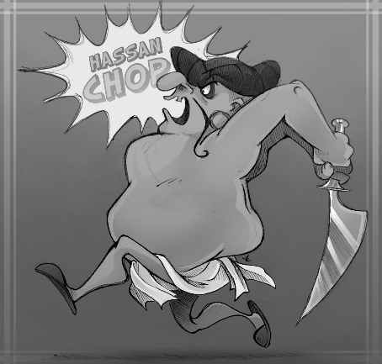
of execution. God required that the murderer’s blood be shed by man. So when God ordained capital punishment, He thereby instituted human government as a restraint against the lawless rebellion of man.

- Romans 13:1-7 indicates that government authority derives its existence from God, that it is for the purpose of restraining evil, and that it functions as the minister of God when it uses the sword for capital punishment.

- Human government, then, with its authority to administer capital punishment, was the new ruling factor in the third dispensation.

- Human conscience and the restraint of the Holy Spirit continued as ruling factors, as indeed they continue today in the current dispensation. (See Romans 2:14-15; 2 Thessalonians 2:7)

- Does this new ruling factor continue today?

- We have government today (Romans 13:1-7) but should capital punishment continue?

“For if I be an offender, or have committed any thing worthy of death, I refuse not to die: but if
there be none of these things whereof these accuse me, no man may deliver me unto them. I
appeal unto Caesar.” Acts 25:11

- The R_______________________: God again commanded man to multiply and populate the earth, but indicated that animals would now have the fear of man, for God now made animals a source of food.

- But animals nor man was to kill man without severe consequences.

- God promised that he would never flood the entire world again

- Man’s R : To obey God on the basis of human conscience, restraint by the Holy Spirit, and human government.

- Man’s T_________________: Would man obey God on the basis of these three ruling factors?

- Man’s F_________________: Noah became drunk, which led to an indiscretion on the part of his son Ham.

- Noah’s descendants rebelled against God’s command to populate the whole earth.

“And they said, Go to, let us build us a city and a tower, whose top may reach unto heaven; and
let us make us a name, lest we be scattered abroad upon the face of the whole earth.”
Genesis 11:4

- In order to prevent their scattering over the whole world, they began to build the city and tower of Babel.

- Man’s J : Up until this time, Noah’s descendants spoke only one language.

“And the whole earth was of one language, and of one speech.” - Genesis 11:1

- This universal language enabled them to work together on their building project until God’s
judgement confused their language.

- For the first time, man began to speak different languages. As with conscience, it was due to man’s rebellion to God.

- This brought the building project to a halt because the builders could no longer understand or communicate with each other.

- Noah’s descendants split up, relocated to other areas and began to repopulate the entire earth.

- Through time, this beginning of different languages caused the development of the nations.

- One of those nations would receive special promises through the call of a man who would then be the father of that nation.

- Thus heralding in another dispensation; the dispensation of P___________________.


THE DISPENSATION OF PROMISE

- The T________________: The Fourth dispensation extended from the call of Abraham to the giving of the Mosaic law at Mount Sinai. Genesis 12 – Exodus 18.

- Since man had failed to obey by the previous ruling factors, God started another dispensation by instituting promise as a new ruling factor.

- The fact that promise began as a significant factor with God’s dealings with Abraham is made evident by the following passages:

- Galatians 3:15-22

- Hebrews 6:13-15

- God intended His promises to Abraham and his descendants to make a difference in the way they would live. Hebrews 11:8-30 demonstrates the fact that God’s promises did make a difference in the lives of Abraham and his descendants, which shows that Promise functioned as a ruling function.


- The fourth dispensation had four ruling factors which God used to govern Abraham
and his descendants. They were
What's This?

a. Human Conscience
b. The Restraint of the Holy Spirit
c. Human Government
d. Divine Promise
- The Revelation: Recorded in Genesis 12:2-3; 13:14-17; 15, 17:1-22 and 22:16-18

- God made P Promises to Abraham.

a. He would bless him
What's This?


b. make his name great
c. give him many physical descendants
d. make him the father of a multitude of nations
e. give him the land of Canaan for an everlasting possession
f. bless those who bless him and curse those who curse him.

- God made N Promises concerning Israel

a. He would bring Israel into existence as a nation and make it great
b. give Israel the land of Canaan forever
c. establish the Abrahamic Covenant with the nation as an everlasting covenant

- God made a U Promise.

a. He would give blessing to all the families of the earth through Abraham’s line of
descendent. The Redeemer would come through Israel

- The Responsibility of man (particularly Abraham and his descendants) was to obey God on the basis of the four ruling factors

- The T : Would they obey God on the basis of the four ruling factors?

- The Failure of Abraham and his descendants: On several occasions they disobeyed God as the result of lapses of faith concerning the fulfillment of God’s promises
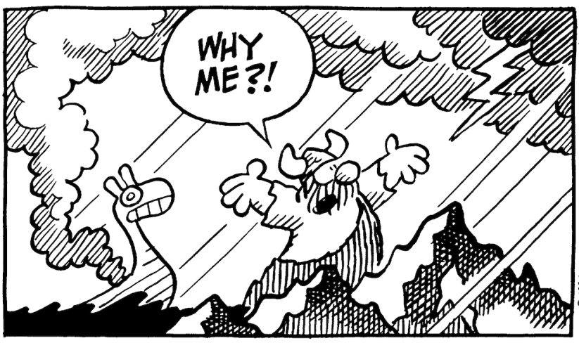
a. Abraham fathered Ishmael through
Sarah’s maid Hagar.
b. Abraham lied twice concerning his
wife Sarah.
c. Isaac lied concerning Rebekah
d. Jacob was a deceiver
e. The Jews did not return from Egypt
to Canaan after the famine of
Joseph’s time ended. Apparently
they forgot that their destiny was
related to the land of Canaan rather
than Egypt.

- The J : Throughout their history, the Jews have continued to have problems with Ishmael’s descendants. Through time, they have been subjected to slavery and threatened with annihilation in Egypt.

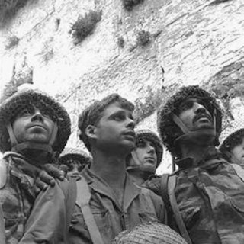
“Paratroopers at the Western Wall” is an iconic photograph taken on June 7, 1967, by David Rubinger. The photograph depicts three Israeli paratroopers framed against the Western Wall in the Old City of Jerusalem, shortly after its capture by Israeli forces in the Six-Day War also known as the June War, the 1967 Arab–Israeli War, or Third Arab–Israeli War, which was fought between 5th and 10th June 1967 between Israel and Jordan, Syria, and Egypt.
From left to right, the Israeli soldiers photographed are Zion Karasenti, Yitzhak Yifat, and Haim Oshri. The soldiers were reservists of the 66th Battalion, 55th Paratroopers Brigade.
The image engenders such a strong emotional component that it has become an icon of Israel. Israeli Supreme Court Justice Misha'el Kheshin declared in 2001 that the photo had "become the property of the entire nation".

THE DISPENSATION OF THE M_______________________________________
- The Time of the 5th Dispensation, from the giving of the law at Mount Sinai to the death of Christ at Mount Calvary. Exodus 19:1 – Matthew 27:56; Mark 15:41; Luke 23:49; John 20:30
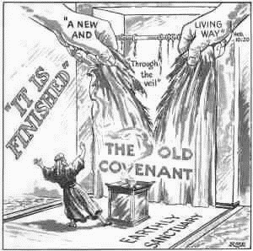
- The tearing of the veil in the Temple in Jerusalem when Christ died, indicated that the law was terminated at that time.

- Since Abraham and his descendants had failed to obey God on the basis of the four ruling factors of the fourth dispensation, God began a fifth dispensation by instituting the Mosaic law as a new ruling factor.

- The central core of the Mosaic Law was written on tables (i.e., tablets) of stone.

- The Law inflicted the death penalty upon those who broke a number of its precepts.

- In total. there were 36 capital offences that warranted the death penalty.

They included:

I (Exodus 22:20; Numbers 25:1-9; Deuteronomy 17:2-7)
False prophecy (Deuteronomy 13:1-10; 18:20-22 )
Occult practices (Exodus 22:18; Leviticus 20:27)
Blasphemy (Leviticus 24:10-16)
Sabbath breaking (Exodus 31:14; 35:2; Numbers 15:32-36
Foreigners getting close to the tabernacle (Numbers 1:51; 3:10,38)
Rape in an isolated place (Deuteronomy 22:25-27)
Fornication (Deuteronomy 22:13-24)
Adultery (Leviticus 20:10)
Marrying one’s wife’s mother (Leviticus 20:14)
Incest with a father’s wife or daughter in law (Leviticus 20:11,12)
Homosexuality (Leviticus 18:22; 20:13)
Bestiality (Exodus 22:19; Leviticus 20:15,16)
Murder (Exodus 21:12-14; Leviticus 24:17-23; Numbers 35:9-34)
Manslaughter by means of negligence (Exodus 21:28-32)
Striking a parent (Exodus 21:15)
Cursing a parent (Exodus 21:17; Leviticus 20:9)
Contempt of court, i.e., disobeying the decision of a court (Deuteronomy 17:8-13)
Being a False witness to a capital crime (Deuteronomy 19:15-21)
Kidnapping (Exodus 21:16; Deuteronomy 24:7)

- The Mosaic Law was a totally external way of God administering His rule over Israel.

- For this reason, the Apostle Paul declared that the Mosaic Law functioned as a
“ ” (an external moral restrainer)
“But before faith came, we were kept under the law, shut up unto the faith which should afterwards be revealed. Wherefore the law was our schoolmaster to bring us unto Christ, that we might be justified by faith. But after that faith is come, we are no longer under a schoolmaster.” (Gal. 3:23-25)
- The Special R which God gave to Israel at that time is recorded in Exodus 20 through to the end of the book of Deuteronomy.

- It consisted of the Mosaic Law with its commandments.

- These gave detailed instructions for carrying out God’s will in

M ,
C .
and C aspects of Israel’s life.

- Israel’s Responsibility was to obey God on the basis of

- Human Conscience

- The Restraint of the Holy Spirit

- Human government

- Promise

- Mosaic Law

NOTE: This Law was not given to the entire world, but to I________________ only.
“These are the statutes and judgments and laws, which the LORD made between him and the children of
Israel in mount Sinai by the hand of Moses.” (Leviticus 26:46)

“And what nation is there so great, that hath statutes and judgments so righteous as all this law, which I
set before you this day?” (Deuteronomy 4:8)

“For when the Gentiles, which have not the law, do by nature the things contained in the law, these,
having not the law, are a law unto themselves:” (Romans 2:14)

- The Test: Would Israel obey God on the basis of these five ruling factors?

- The Failure: The people of Israel repeatedly failed the test of the fifth dispensation.

“Not according to the covenant that I made with their fathers in the day that I took them by the hand
to bring them out of the land of Egypt; which My covenant they brake, although I was an husband
unto them, saith the LORD. ” (Jeremiah 31:32)

“Did not Moses give you the law, and yet none of you keepeth the law?” (John 7:19)

“Who have received the law by the disposition of angels, and have not kept it.” (Acts 7:53)

- God told them that they had a heart of s .

“Yea, they made their hearts as an adamant stone, lest they should hear the law, and the words which the LORD of hosts hath sent in His Spirit by the former prophets: therefore came a great wrath from the LORD of hosts.” (Zechariah 7:12)

See also Ezekiel 36:26

- This was God’s way of saying that their inner control centre was inflexible, and refused to bend and conform to the Mosaic Law as an expression of God’s rule over them.

- Also, during this dispensation, Israel rejected its Messiah and had Him crucified.

- The Judgement: The nation of Israel suffered many judgements during this dispensation.

- The worst were the Assyrian and Babylonian captivities, and Israel’s temporary removal from its place of blessing, the land of Israel, and its worldwide dispersion as a result of its rejection of Christ.

NOTE: The Mosaic Law never functioned as a way of salvation, but it did function as a rule of life (a ruling
factor).

“Knowing that a man is not justified by the works of the law, but by the faith of Jesus Christ, even we have
believed in Jesus Christ, that we might be justified by the faith of Christ, and not by the works of the law: for
by the works of the law shall no flesh be justified.” (Galatians 2:16)

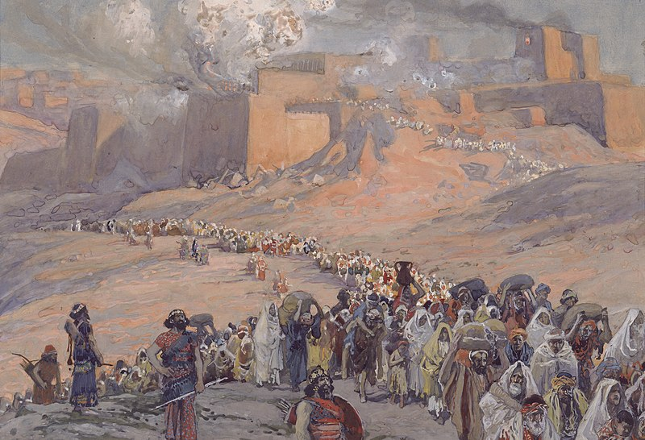

THE DISPENSATION OF G_______________________________________
“For the law was given by Moses, but grace and truth came by Jesus Christ.” (John 1:17)

- Although grace was functioning throughout the Old Testament times (e.g., Noah found grace in the eyes of the Lord [Genesis 6:8]; Israel was restored to its homeland after the Babylonian captivity [Ezra 9:8]; and the afflicted were sustained in their trials [Proverbs 3:34]) it began to function in some new sense as a result of the ministry of Jesus Christ during His first coming.

- John appeared to be making this new function of grace parallel with the function of the Mosaic Law. The Mosaic law never functioned as a way of salvation, but it did function as a rule of life (a ruling factor). In light of this, John is saying that grace began to function as a rule of life (a ruling factor) as a result of Christ’s ministry in His first coming.

- Paul wrote to believers in the present time of the 6th dispensation, “ye are not under law, but under grace.” (Romans 6:14) That is, we are not under the rule of the law of Moses, but are under the rule of grace. Grace has now taken over the function which the Mosaic Law had in the previous dispensation.

“For the grace of God that bringeth salvation hath appeared to all men, Teaching us that, denying
ungodliness and worldly lusts, we should live soberly, righteously, and godly, in this present
world;” (Titus 2:11,12)

- Far from the idea that grace would lead us into loose living; “What shall we say then? Shall we continue in sin, that grace may abound?God forbid. How shall we, that are dead to sin, live any longer therein?” (Romans 6:1,2, see also 1 Corinthians 9:21 and Jude 4), grace practices discipline over believers by guidance and correction for the purpose of prompting them to reject an ungodly lifestyle and to adopt a one of soberness (i.e., self control), righteousness and godliness.

- Paul stated that grace functions as a ruling factor “in this present world (the word translated “world” means age).”

- The sixth dispensation extends from the death of Christ to His Second Coming. The Scripture portion which covers this dispensation is Matthew 27:57; Mark 15:42; Luke 23:50; and John 19:31 through to Revelation 4:1

“For all the prophets and the law prophesied until John.” (Matthew 11:13)

“The law and the prophets were until John: …” (Luke 16:16)

- Note: “the prophets always called Israel back to the Mosaic Law, for this was the governing arrangement under which they lived.” (Ryrie, Charles C.. Dispensationalism (p. 49). Moody Publishers. Kindle Edition.)

“But when the fulness of the time was come, God sent forth his Son, made of a woman, made under
the law, To redeem them that were under the law, that we might receive the adoption of sons.”
(Galatians 4:4,5)

“Wherefore then serveth the law? It was added because of transgressions, till the seed should come
to whom the promise was made…” (Galatians 3:19)

- The sixth dispensation has five ruling factors which God uses to govern people:

- Human conscience

- The Restraint of the Holy Spirit (This will be removed as a ruling factor when it is time for the Beast [Antichrist] to be revealed at the end of the dispensation of grace)

- Human Government

- Promise

- Grace (The Mosaic Law is not a ruling factor in the present dispensation of Grace)

- As a ruling factor in the life of a believer, grace consists of two things:

- A confirmed favourable disposition toward God (the law of God in the heart)

“For I delight in the law of God after the inward man:” (Romans 7:22) (See also 2 Corinthians
3:3-11; Hebrews 8:8-12)

- The indwelling Holy Spirit

- What? know ye not that your body is the temple of the Holy Ghost which is in you, which ye have of God, and ye are not your own? For ye are bought with a price: therefore glorify God in your body, and in your spirit, which are God's.” (1 Corinthians 6:19,20)

- The special Revelation which God gave for this sixth dispensation is recorded in the latter part of the Gospels, the Book of Acts, the Epistles and parts of the book of Revelation

